Students, Scholarships & Studebakers Submitted by James Bell

It’s always wonderful to see younger people have an interest in Studebaker vehicles and want to keep the legacy alive. Since one of the goals for the Studebaker National Foundation is providing Scholarships for such students, it’s nice for people to see a recipient and how it effects their future.
Michael Figueroa is a SNF Scholarship recipient who gained interest and inspiration from his Teacher and Studebakers at Carson High School in California.
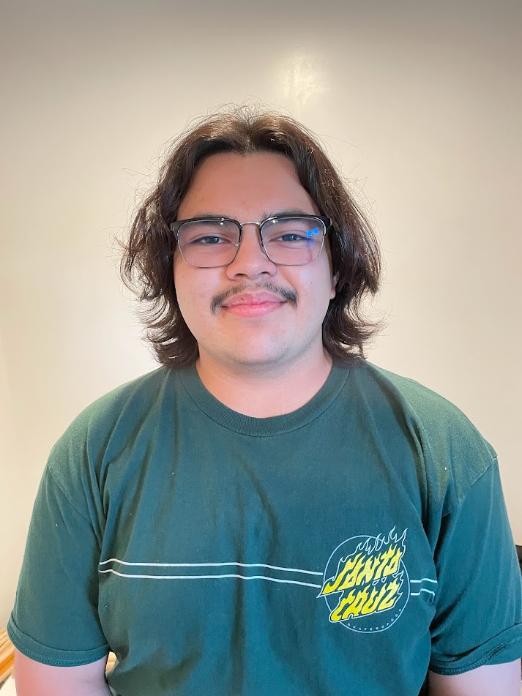

Hello, I’m Michael Figueroa a soon-to-be Freshman at the University of California San Diego. I luckily received the scholarship from Studebaker National Foundation. First, I want to thank the Studebaker National Foundation for the scholarship because it will help me pay for college. My interest in Studebakers took off when I enrolled in the auto mechanic class at Carson High school which is run by Robert Roach. Mr. Roach is a great guy and advocated applying for the scholarship and although the program isn’t funded compared to the other programs, he still tries his best and puts monumental effort into the program to help teach kids about cars and their inner workings. Further on, I loved his class and that is what brought on my inspiration for mechanical engineering. The class also got me to look at much older cars as well because SNF had donated cars to the program. One of the trucks Mr. Roach was able to fully restore which really grew my interest in Studebaker since it was my first exposure to the make. I also do want to restore some old cars, this ranges from a Studebaker Champion to a Porsche Carrera RSR 911. In the future, I do want to give back once I become a mechanical engineer and help the people who helped me such as the SNF, I am very thankful for the scholarship and deeply indebted to them and the scholarship will help monumentally.

